Short title Source Serif 4 Bold ~50p

Example of a cover with a micro illustration related
to the topic addressed in the document.
Name and Surname
Madrid, June 2025


Document title with Header style cover1

Header 2 style
Let the pain itself be a lot, consectetuer or that pain eu feugiat no facilisis but vero eros et accumsan quis nostrud exercitation ullamcorper suscipit lobortis nisl so some of it can be beneficial. Duis autem vel eum iriure dolor in hendrerit ullamcorper suscipit loborti sadipiscing elit, sed diam nonummy nibh euismod tincidunt ut laoreet dolore magna aliquam iriure dolor in hendrerit velit esse molestie consequat, vel illum dolore eu feugiat no facilisis at vero eros et accumsan et justo hate dignissim qui blandit present.
Blanditi presents some magma with pain:
- Sonlitous.
- Easier.
- Consecutive.
- Self-righteousness.
Adisipiscing ipsum pain sit amet, consectetuer adipiscing elit, sed diam nonummy nibh euismod tincidunt ut laoreet dolore magna aliquam volutpat:
Lorem ipsum dolor sit amet, consectetuer adipiscing elit, sed diam nonummy nibh euismod tincidunt ut laoreet:
- But for the two of them, either the pain in the hand of the vulputate would be molestie consequat, or that pain in the eu feugiat no facilisis but verily eros and accumsan and just hate.
- Duis, however, or he iriure dolor in hendrerit in vulputate velit esse molestie consequat, or illum eu feugiat no facilisis at Duis.
In order that I may come to the minimum, it is a molestie consequat, or that pain eu feugiat no facilisis at vero eros et accumsan quis nostrud exercitation ullamcorper suscipit lobortis nisl so that some of it is beneficial to consequat. But duis or eum iriure pain in the hendrerit ullamcorper suscipt les lisps so that some of it can be beneficial. Duis, however, either he iriure dolor in hendrerit in vulputate velit esse molestie consequat, or that dolore eu feugiat no facilisis at vero eros et accumsan.

Index

Document title with cover page styled Heading 1 1
Header 2 bronze in easy schools or time always pain 1
Index 2
Second example with Heading 2 style 3
Example Header 3 3
Header 4 donec suscipit mauris sed vulputate aliquet 3
Header 4 phasellus aliquet euismod mauris ac commodo 3
Examples of using color, shapes, and typography in a document 4
Various models of tables and graphs 5
Third example Header 3 garnish sauce 5
Some more models of tables, graphs and multi-column text 6

Second example with Heading 2 style
Cras sed risus est. Praesent scelerisque pharetra mauris, et vestibulum turpis efﬁcitur. Donec scelerisque diam ut eros iaculis, vel ﬁnibus massa posuere. Aliquam aliquam pharetra tellus, vitae accumsan dolor. Praesent scelerisque pharetra mauris, et vestibulum turpis efﬁcitur.
 | Vivamus  sapien | Vivamus sapien orci, pretium vitae velit a, aliquet pellentesque nibh. Curabitur posuere eleifend quam, in pellentesque lectus lacinia eu. Aliquam erat volutpat. Quisque a ultrices dui, in interdum lacus.
 | Phasellus | Phasellus nec arcu ac lorem vulputate accumsan. Quisque arcu lorem, auctor ut mollis quis.
 | Morbi  viverra | Morbi viverra aliquam nisl, quis egestas lectus sagittis in. Integer vitae dui odio. Duis blandit ante at facilisis sodales. Nulla non pretium nunc ipsum leo.
 | tellus vel dignissim | Integer vitae dui odio. Duis blandit ante at facilisis sodales. Nulla non pretium nunc, eu placerat arcu. Quisque semper eleifend tellus vel dignissim.
 | Duis vel  ipsum | Nulla non pretium nunc, eu placerat arcu. Quisque semper eleifend tellus vel dignissim. Duis vel ipsum leo. Fusce consectetur lectus ac est eleifend dignissim.

Example Header 3

Header 4 donec suscipit mauris sed vulputate aliquet
Vitae without sollicitude, eu mattis dolor sodales. Suspendisse magna nunc, ﬁnibus nec magna vulputate, efficiency dictum lake. Cras iaculis mollis augu egg egestas. Name annoyance sapien non augue fringilla, sit amet laoreet metus pharetra.

Second header 4 phasellus aliquet euismod mauris ac commodo

Heading 5
Cras velit happy, rutrum id quam and, imperdiet pregnant diam. Suspended dignity sagittis bibendum. Nullam tempus, massa vel porta pretium, just lorem pulvinar ligula, et fringilla felis elit ut magna.Donec vehicle never and temporary sodales Cras iaculis mollis augu egg egestas sapien non augue fringilla, sit amet.

This highlight is a drawing; you can double-click to edit it and change the text, as well as the dimensions of the rounded
blue box.

Examples of using color, shapes, and typography in a document
Just like with highlights, we can use drawing to highlight different content that will be developed later. In this case, we can change the colors of the shapes to different corporate colors and accents. Drawing will allow us to adjust line spacing, align and distribute boxes and text, etc..
MODULE 01

Section title
Módulo 02
Módulo 03
Módulo 04
Módulo 05
MODULE 02

Section title
MODULE 03

Section title
MODULE 04

Section title
MODULE 05

Section title
MODULE 06

Section title
MODULE 01
Title 1
Bibendum sodales. Aenean in facilis turpis, vel temporary velit. Aliquam always pain me cursus aliquet. Nulla sodales nisi purus, at laoreet erat tincidunt at. Proin conval.
MODULE 02
Title 2
Bibendum sodales. Aenean in facilisis turpis, vel tempor velit. Aliquam semper. Donec suscipit mauris thirst vulputate aliquet. Phasellus pregnant fair urn, id congue lake dapibus quis.Bibendum sodales.
MODULE 03
Title 3
Bibendum sodales. Aenean in facilisis turpis, vel tempor velit. Aliquam semper dolor eu aliquet cursus. Nulla sodales nisi purus, at laoreet erat tincidunt at. Proin convallis purus to condimentum ornare. enean in facilisis turpis, vel tempor velit. Aliquam semper. Donec suscipit mauris thirst vulputate aliquet.

Various models of tables and graphs
Example of a table with a rounded header. It has its own title because there is a column heading. It's embedded as a drawing, can be edited by double-clicking, and can be linked from your Google Sheet table.

SEGMENTATION BY COUNTRIES

Third example Header 3 garnish sauce
Text simulated here. Members must drink. Aenean in the easy schools, or the time he wants. There is always a pain in football trucks running. There were no members but pure, but the law was the tincidunt at. Garnish the pasta with pure sauce. It's a good idea, but what's the difference?
Text here |  | Development of the idea highlighted on the left of this text. Bibendum sodales. Aenean in facilisis turpis, vel tempor velit. purus, at laoreet erat tincidunt at. Proin convallis purus a condimentum ornare. Donec suscipitated.

Some more models of tables, graphs and multi-column text
Example of a table with a rounded header. The table title is equivalent to the first column header. It's embedded as a drawing, can be edited by double-clicking, and can be linked from your Google Sheets table.

In order that I may come to the minimum, it is a molestie consequat, or that pain eu feugiat no facilisis at vero eros et accumsan quis nostrud exercitation ullamcorper suscipit lobortis nisl so that some of it is beneficial to consequat. But duis or eum iriure pain in the hendrerit ullamcorper suscipt les lisps so that some of it can be beneficial. Duis, however, either he iriure dolor in hendrerit in vulputate velit esse molestie consequat, or that dolore eu feugiat no facilisis at vero eros et accumsan. But duis or eum iriure pain in the hendrerit ullamcorper suscipt les lisps so that some of it can be beneficial. Duis, however, either he iriure dolor in hendrerit in vulputate velit esse molestie consequat, or that dolore eu feugiat no facilisis at vero eros et accumsan.

COLUMN CHART |  | SECTOR CHART
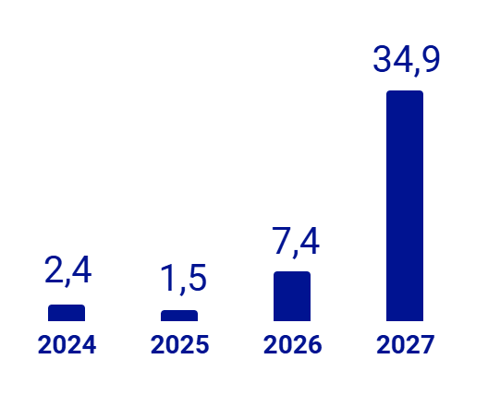 |  | 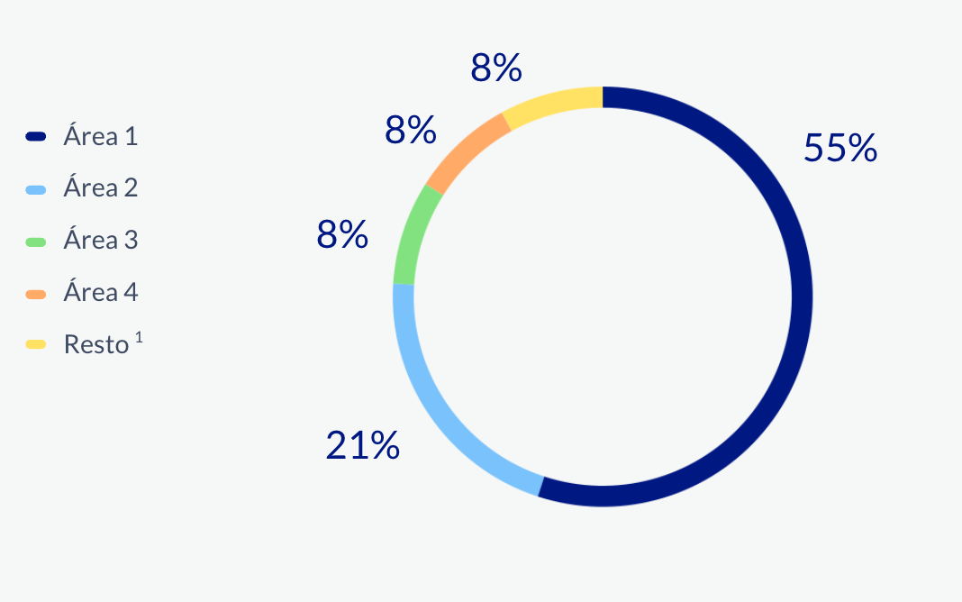
Source: Lato 8 Normal Color gray-3 #46536d |  | Source: Lato 8 Normal Color gray-3 #46536d



SECTOR CHART
COLUMN CHART
Area 1
Area 2
Area 3
Area 4
Rest
55%
8%
8%
8%
21%

Source: Lato 8 Normal Color gris-3 #46536d
Below are examples of texts arranged in columns, both in drawing and table mode. In the example, we have two blocks of ideas that can be Pros and Cons, etc.
In the first case it is possible to incorporate boxes rounded icons with stickers in a practical way.


Right column
Idea 4.
Idea 5.
Idea 6.
Left column
Idea 1.
Idea 2.
Idea 3.
If more direct access is required to modify the text, it can also be done in table mode:
 |  | 
Left column |  | Right column
- Idea 1.  - Idea 2.  - Idea 3. |  | - Idea 3.  - Idea 4.  - Idea 5.
Below are examples of text arranged in columns, both in drawing mode and table mode. Shapes and colors can be used in drawing mode, as shown below:

NOSTRUD EXERCI TATION
Paragraph 1
Donec luctus sapien gravida posuere porttitor.

Paragraph 2
Donec vehicula nunc et sodales tempor. Sed mollis nisi.

ULLAMCORPER SUSCIPIT
Paragraph 1
Donec luctus sapien gravida posuere porttitor.

Paragraph 2
Donec vehicula nunc et sodales tempor. Sed mollis.

LOBORTIS NISL UT ALIQUIP
Paragraph 1
Donec luctus sapien gravida posuere porttitor.

Paragraph 2
Donec vehicula nunc et sodales tempor.

EX EA COMMODO CONSEQUAT
Paragraph 1
Donec luctus sapien gravida posuere porttitor.

Paragraph 2
Sed mollis, risus eget feugiat sodales.

DUIS AUTEM VEL EUM IRIURE DOLOR
Paragraph 1
Donec luctus sapien gravida posuere porttitor.

Paragraph 2
Donec vehicula nunc et sodales tempor. Sed mollis.

In table mode, we have more direct access to editing the text:
Heading 1 | Heading 2 | Heading 3 | Heading 4 | Heading 5
Aenean in the easy schools, or the time he wants. | The boat is just pregnant, that's the homework of the lake. | Aenean in the easy schools, or the time he wants. | The boat is just pregnant, that's the homework of the lake. | Something always. Don't worry, it's a good idea. The boat was just pregnant
Below is shown another example of information layout to show several grouped ideas. In this case, in two rows and several columns:
Lorem ipsum dolor sit amet, consectetur adipiscing elit. In condimentum nisi lorem, ut congue metus efficitur id. Nunc id quam sed lectus bibendum sodales.
Aenean in facilisis turpis, vel tempor velit. Aliquam semper dolor eu aliquet cursus. Nulla sodales nisi purus, at laoreet erat tincidunt at.
Proin convallis purus a condimentum ornare. Donec suscipit mauris sed vulputate aliquet. Phasellus gravida justo urna, id congue lacus dapibus quis.
First row
Second row
Lorem ipsum dolor sit amet, consectetur adipiscing elit. In condimentum nisi lorem, ut congue metus efficitur id. Nunc id quam sed lectus bibendum sodales.

Aenean in facilisis turpis, vel tempor velit. Aliquam semper dolor eu aliquet cursus. Nulla sodales nisi purus, at laoreet erat tincidunt at.

Proin convallis purus a condimentum ornare. Donec suscipit mauris sed vulputate aliquet. Phasellus gravida justo urna, id congue lacus dapibus quis.
COLUMN 1
COLUMN 2
COLUMN 3
COLUMN 1
COLUMN 2
COLUMN 3
Another example of information organization is also included to show four ideas subordinate to a main or introductory one, in this case as text within a table:
Text that heads or represents the main idea.  Your text here, your text here, your text here, your text here, your text here. | Subordinate idea 1  Explanatory text of the first subordinate idea. | Subordinate idea 2  Explanatory text of the second subordinate idea.
 | Subordinate idea 3  Explanatory text of the third subordinate idea. | Subordinate idea 4  Explanatory text of the fourth subordinate idea.

This is another example of how a timeline can be represented using the drawing tool.

JUN
2025

JUL
2025
AGO
2025
SEP
2025
OCT
2025
NOV
2025
DIC
2025
ENE
2026
FEB
2026
MAR
2026

Text here

Text here

Text here

Text here

Text here

Text here

 | Example of the conclusion.

